**Generate hash for the zip file:**

zip2john sample.txt.zip

**Store the hash in a txt file:**

zip2john sample.txt.zip > password.hash

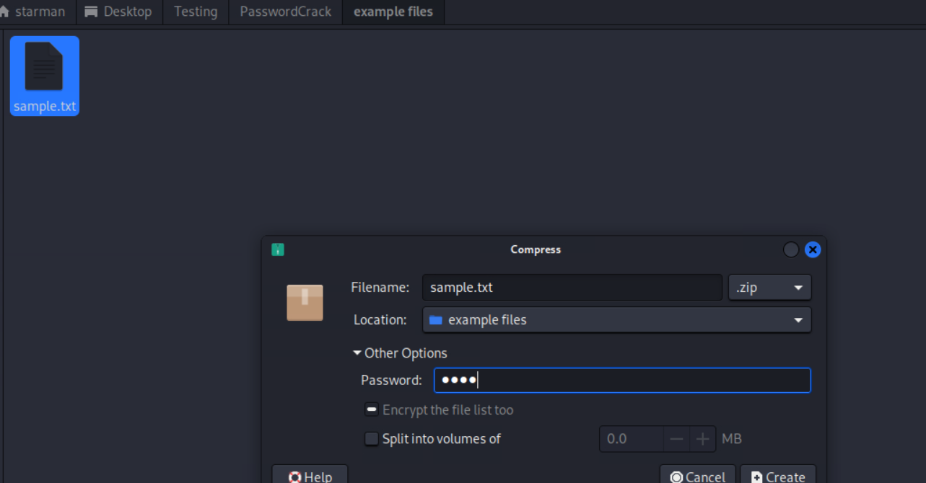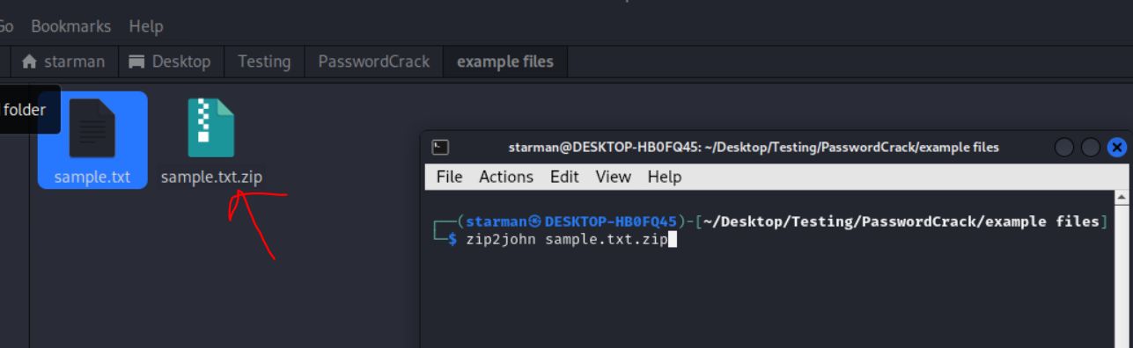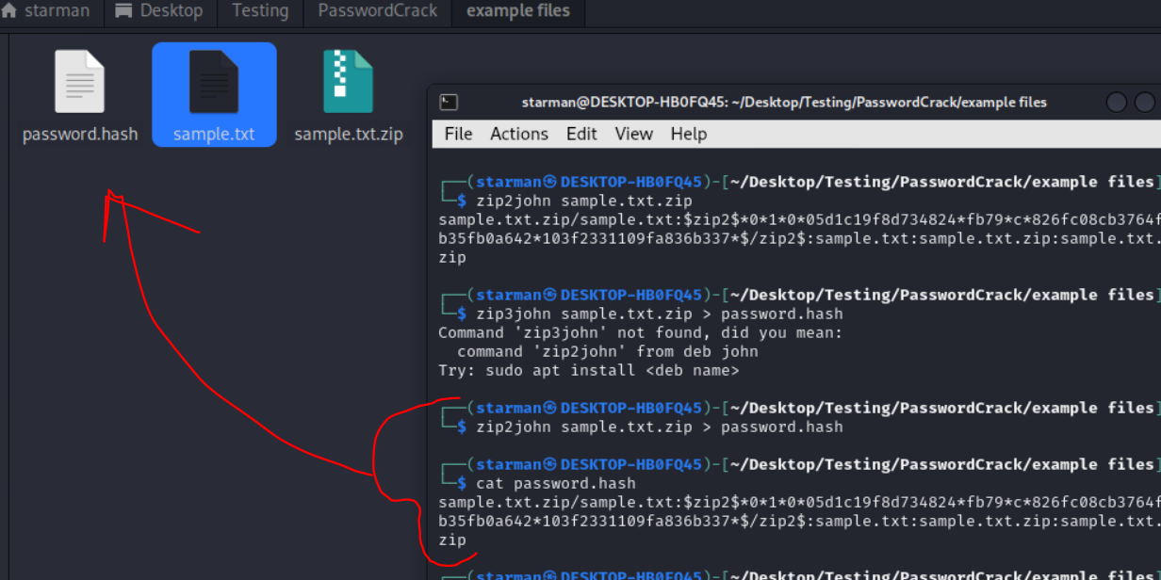

Crack password with default wordlist:

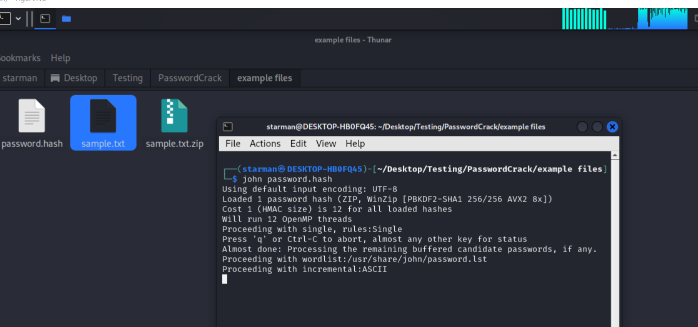

With custom wordlist:

john --wordlist=/usr/share/john/password.lst